**OpenCV:Python**

import cv2 as cv  
import numpy as np  
  
image = cv.imread('C:/Users/amazon/Desktop/trendy-mehndi-bangles-set-for-ladies_44168.webp')  
height = image.shape[0]  
width = image.shape[1]  
cv.line(image, (20, 10), (100, 10), (0, 0, 0), 12)  
cv.line(image, (0, 0), (width, height), (0, 255, 0), 12)  
cv.imshow("image",image)  
cv.waitKey(0)  
cv.destroyAllWindows()

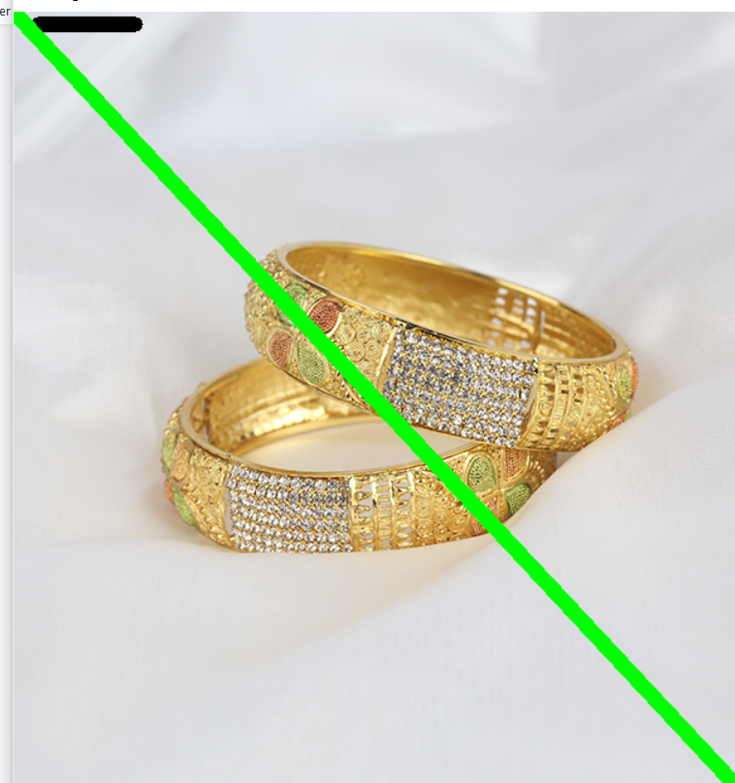

import cv2 as cv  
import numpy as np  
W = 400  
def my_ellipse(img, angle):  
 thickness = 2  
 line_type = 8  
 cv.ellipse(img,  
 (W // 2, W // 2),  
 (W // 4, W // 16),  
 angle,  
 0,  
 360,  
 (255, 0, 0),  
 thickness,  
 line_type)  
def my_filled_circle(img, center):  
 thickness = -1  
 line_type = 8  
 cv.circle(img,  
 center,  
 W // 32,  
 (0, 0, 255),  
 thickness,  
 line_type)  
def my_polygon(img):  
 line_type = 8  
 # Create some points  
 ppt = np.array([[W / 4, 7 * W / 8], [3 * W / 4, 7 * W / 8],  
 [3 * W / 4, 13 * W / 16], [11 * W / 16, 13 * W / 16],  
 [19 * W / 32, 3 * W / 8], [3 * W / 4, 3 * W / 8],  
 [3 * W / 4, W / 8], [26 * W / 40, W / 8],  
 [26 * W / 40, W / 4], [22 * W / 40, W / 4],  
 [22 * W / 40, W / 8], [18 * W / 40, W / 8],  
 [18 * W / 40, W / 4], [14 * W / 40, W / 4],  
 [14 * W / 40, W / 8], [W / 4, W / 8],  
 [W / 4, 3 * W / 8], [13 * W / 32, 3 * W / 8],  
 [5 * W / 16, 13 * W / 16], [W / 4, 13 * W / 16]], np.int32)  
 ppt = ppt.reshape((-1, 1, 2))  
 cv.fillPoly(img, [ppt], (255, 255, 255), line_type)  
 # Only drawind the lines would be:  
 # cv.polylines(img, [ppt], True, (255, 0, 255), line_type)  
def my_line(img, start, end):  
 thickness = 2  
 line_type = 8  
 cv.line(img,  
 start,  
 end,  
 (0, 0, 0),  
 thickness,  
 line_type)  
atom_window = "Drawing 1: Atom"  
rook_window = "Drawing 2: Rook"  
# Create black empty images  
size = W, W, 3  
atom_image = np.zeros(size, dtype=np.uint8)  
rook_image = np.zeros(size, dtype=np.uint8)  
# 1.a. Creating ellipses  
my_ellipse(atom_image, 90)  
my_ellipse(atom_image, 0)  
my_ellipse(atom_image, 45)  
my_ellipse(atom_image, -45)  
# 1.b. Creating circles  
my_filled_circle(atom_image, (W // 2, W // 2))  
# 2. Draw a rook  
# ------------------  
# 2.a. Create a convex polygon  
my_polygon(rook_image)  
cv.rectangle(rook_image,  
 (0, 7 * W // 8),  
 (W, W),  
 (0, 255, 255),  
 -1,  
 8)  
# 2.c. Create a few lines  
my_line(rook_image, (0, 15 * W // 16), (W, 15 * W // 16))  
my_line(rook_image, (W // 4, 7 * W // 8), (W // 4, W))  
my_line(rook_image, (W // 2, 7 * W // 8), (W // 2, W))  
my_line(rook_image, (3 * W // 4, 7 * W // 8), (3 * W // 4, W))  
cv.imshow(atom_window, atom_image)  
cv.moveWindow(atom_window, 0, 200)  
cv.imshow(rook_window, rook_image)  
cv.moveWindow(rook_window, W, 200)  
cv.waitKey(0)  
cv.destroyAllWindows()

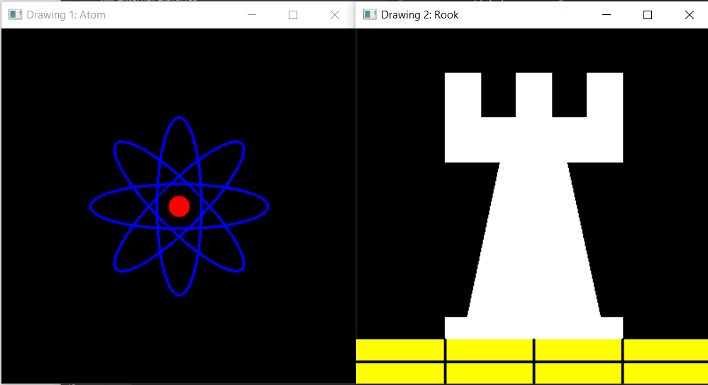

import cv2 as cv  
import numpy as np  
image=cv.imread('C:/Users/amazon/Desktop/trendy-mehndi-bangles-set-for-ladies_44168.webp')  
window_name='image'  
starting_point=(5,5)  
ending_point=(200,200)  
# for color we have  
color=(255,0,0)  
thickness=2  
image=cv.rectangle(image,starting_point,ending_point,color,thickness)  
cv.imshow("Necklace",image)  
cv.waitKey(0)  
cv.destroyAllWindows()

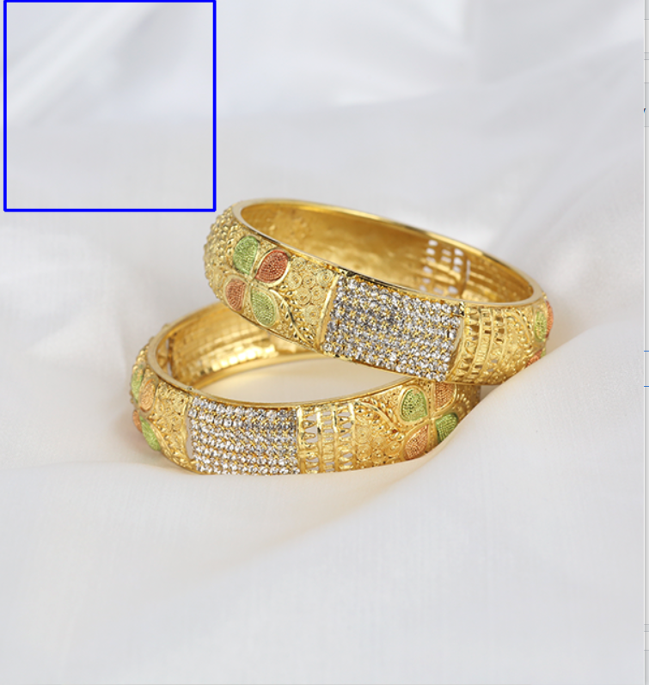

import cv2 as cv  
import numpy as np  
image=cv.imread('C:/Users/amazon/Desktop/trendy-mehndi-bangles-set-for-ladies_44168.webp')  
window_name='image'  
starting_point=(100,100)  
ending_point=(200,200)  
# for color we have  
color=(0,0,0) # for black  
thickness=-1 # thickness of -1 px  
image=cv.rectangle(image,starting_point,ending_point,color,thickness)  
cv.imshow("Necklace",image)  
cv.waitKey(0)  
cv.destroyAllWindows()

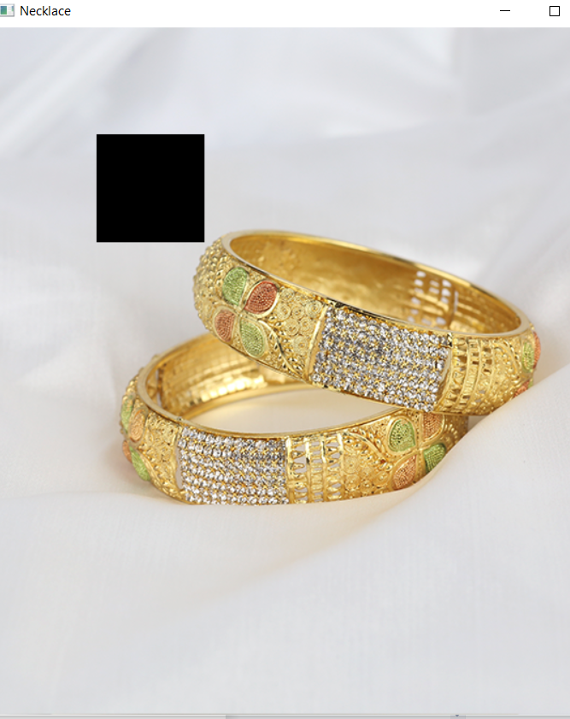

import cv2 as cv  
import numpy as np  
  
image = cv.imread('C:/Users/amazon/Desktop/trendy-mehndi-bangles-set-for-ladies_44168.webp')  
window_name='Necklace'  
font=cv.FONT_HERSHEY_SIMPLEX  
org=(100,100)  
text='Ajman khan wazir'  
fontscale=1  
color=(255,0,0)  
thickness=4  
linetype=0  
botomlinetype=0  
image=cv.putText(image,text,org,font,fontscale,color,thickness,linetype,botomlinetype)  
cv.imshow('necklace',image)  
cv.waitKey(0)  
cv.destroyAllWindows()

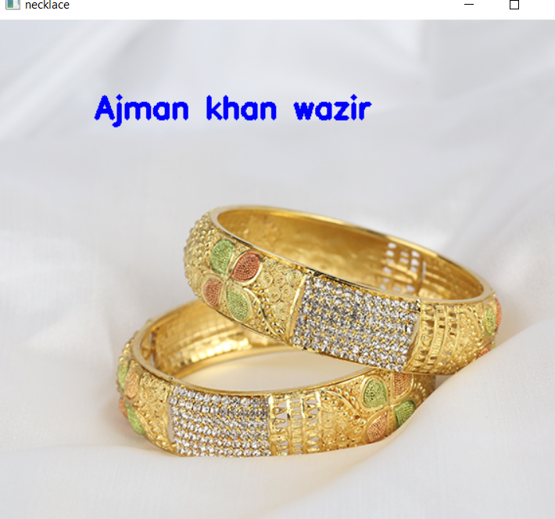

import cv2 as cv  
import numpy as np  
  
image = cv.imread('C:/Users/amazon/Desktop/trendy-mehndi-bangles-set-for-ladies_44168.webp')  
window_name='Necklace'  
font=cv.FONT_HERSHEY_SIMPLEX  
org=(100,100)  
text='Ajman khan wazir'  
fontscale=1  
color=(255,0,0)  
thickness=2  
linetype= cv.LINE_AA  
botomlinetype=False  
botomlinetype2=True  
image=cv.putText(image,text,org,font,fontscale,color,thickness,linetype,botomlinetype)  
image=cv.putText(image,text,org,font,fontscale,color,thickness,linetype,botomlinetype2)  
cv.imshow('necklace',image)  
cv.waitKey(0)  
cv.destroyAllWindows()

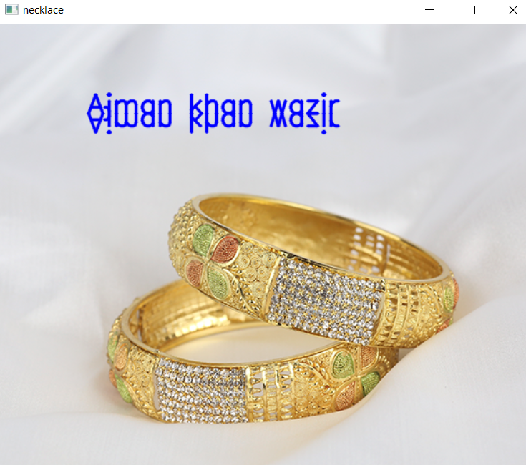

import cv2 as cv  
import numpy as np  
image=cv.imread('C:/Users/amazon/Desktop/trendy-mehndi-bangles-set-for-ladies_44168.webp')  
window_name='image'  
center_cod=(220,50)  
radius=40  
color=(2550,0,0)  
thickness=2  
image=cv.circle(image,center_cod,radius,color,thickness)  
cv.imshow('nicklace ',image)  
cv.waitKey(0)  
cv.destroyAllWindows()

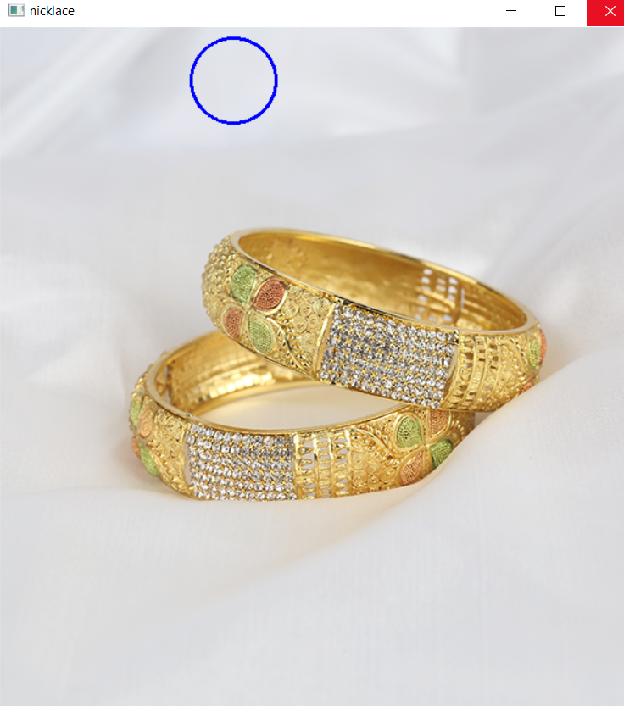

import cv2 as cv  
import numpy as np  
image=cv.imread('C:/Users/amazon/Desktop/trendy-mehndi-bangles-set-for-ladies_44168.webp')  
window_name='image'  
center_cod=(120,100)  
radius=30  
color=(0,0,255)  
thickness=-1 # it will fill the above coller  
image=cv.circle(image,center_cod,radius,color,thickness)  
cv.imshow('nicklace ',image)  
cv.waitKey(0)  
cv.destroyAllWindows()

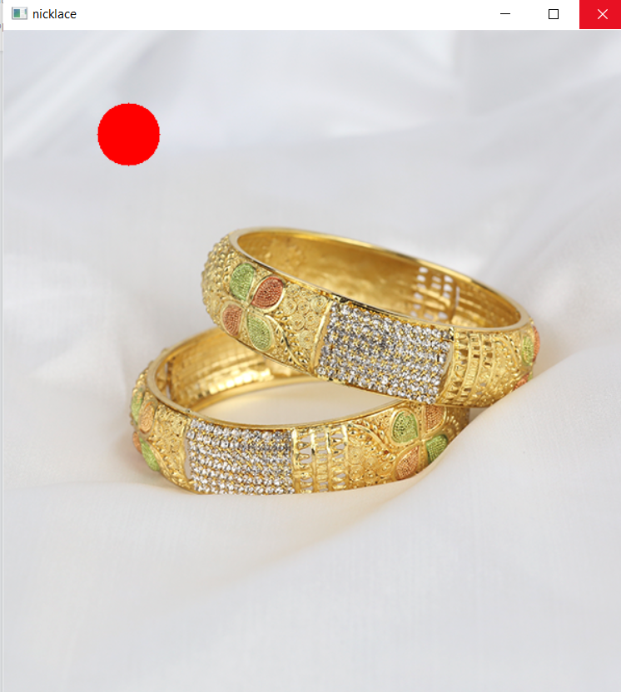

import cv2 as cv  
import numpy as np  
  
image = cv.imread('C:/Users/amazon/Desktop/trendy-mehndi-bangles-set-for-ladies_44168.webp')  
start_point=(255,0)  
End_point=(0,255)  
thickness=2  
color=(0,255,0)  
image1=cv.line(image,start_point,End_point,color,thickness)  
image2=cv.line(image,(125,255),(255,100),(255,0,0),4)  
cv.imshow('nicklace',image1)  
cv.imshow('nicklace2',image2)  
cv.waitKey(0)  
cv.destroyAllWindows()

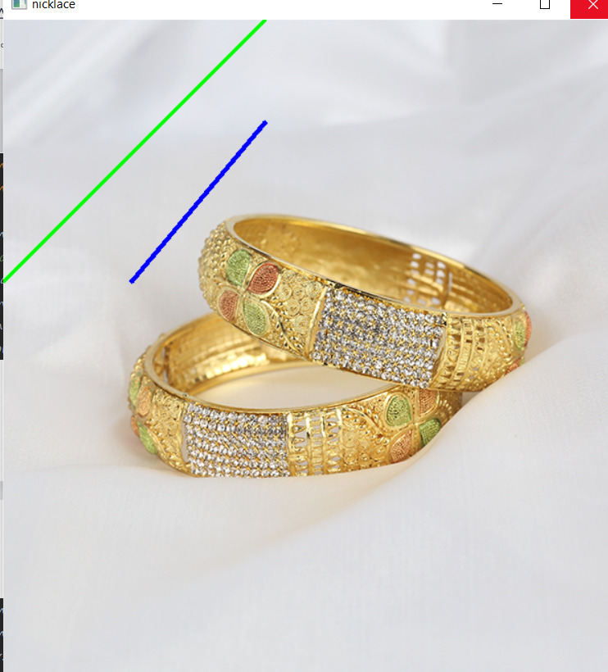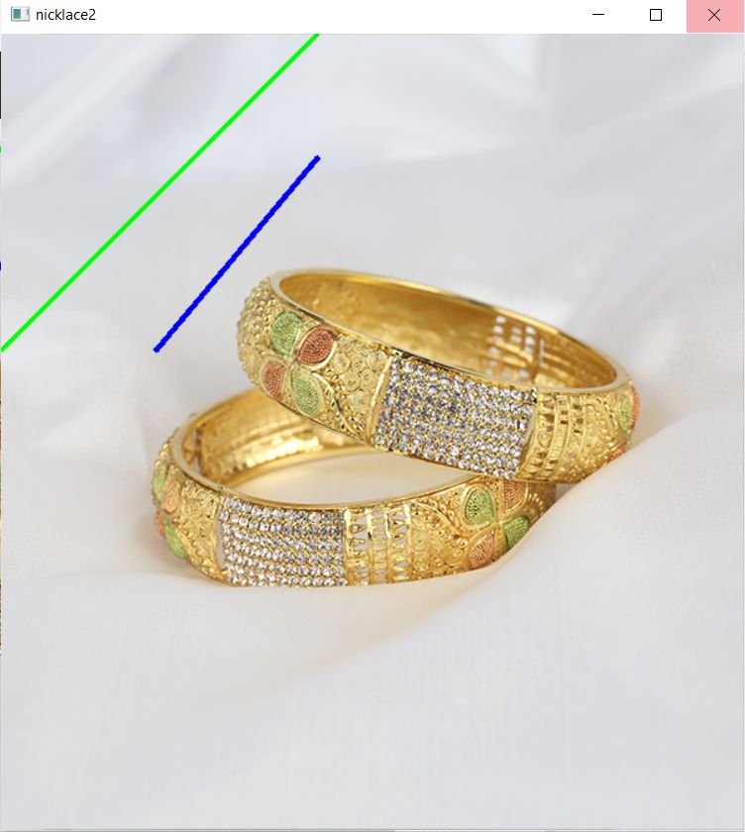

import cv2 as cv  
import numpy as np  
  
image = cv.imread('C:/Users/amazon/Desktop/trendy-mehndi-bangles-set-for-ladies_44168.webp')  
# Polygon corner points coordinates  
pts = np.array([[25, 70], [25, 160],  
 [110, 200], [200, 160],  
 [200, 70], [110, 20]],  
 np.int32)  
pts = pts.reshape((-1, 1, 2))  
isClosed = True  
color=(255,0,0)  
thickness=2  
image=cv.polylines(image,[pts],isClosed,color,thickness)  
# Displaying the image  
while (1):  
 cv.imshow('image', image)  
 if cv.waitKey(20) & 0xFF == 27:  
 break  
cv.destroyAllWindows()

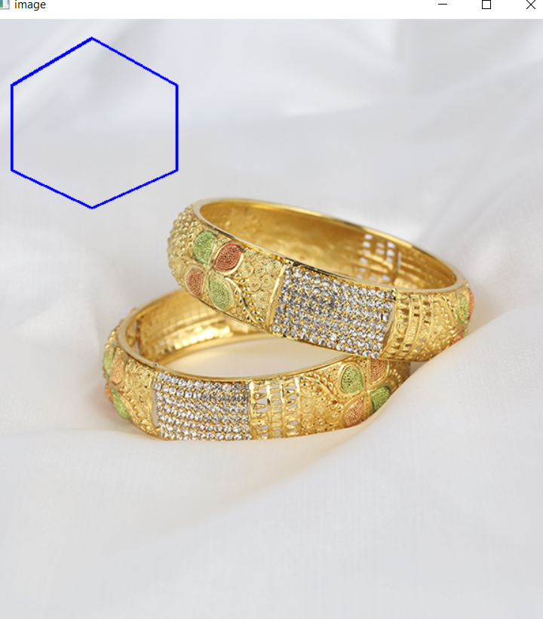

import cv2 as cv  
import numpy as np  
  
image = cv.imread('C:/Users/amazon/Desktop/trendy-mehndi-bangles-set-for-ladies_44168.webp')  
# Polygon corner points coordinates  
pts = np.array([[25, 70], [25, 145],  
 [75, 190], [150, 190],  
 [200, 145], [200, 70],  
 [150, 25], [75, 25]],  
 np.int32)  
pts = pts.reshape((-1, 1, 2))  
isClosed = True  
color=(255,0,0)  
thickness=8  
image=cv.polylines(image,[pts],isClosed,color,thickness)  
# Displaying the image  
while (1):  
 cv.imshow('image', image)  
 if cv.waitKey(20) & 0xFF == 27:  
 break  
cv.destroyAllWindows()

